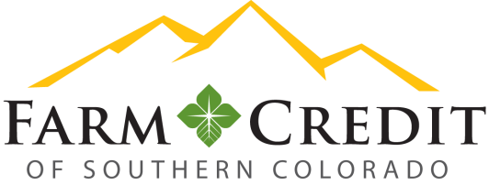

Colorado Springs Office – Compliance Officer Posting

DATE POSTED: November 21, 2018

POSITION: Compliance Officer

LOCATION: Colorado Springs, CO

Farm Credit of Southern Colorado (FCSC) is seeking a Compliance Officer to join our growing team!

Today, the Farm Credit System is one of the strongest, most financially sound lending institutions in the U.S. Its 70 institutions serve our country’s farmers and ranchers, rural America, and agribusiness.

Organizational Information
As one of the Farm Credit System’s associations, Farm Credit of Southern Colorado is a robust organization serving 1,300 member / owners in 31 counties throughout Southern Colorado. Over $1 billion in assets, Farm Credit of Southern Colorado’s approximately 70 staff members bring strength to its shareholders and communities.

Farm Credit of Southern Colorado is a member-owned cooperative that provides a wide range of financial products and risk management services for agricultural producers, agribusinesses, and farmland and rural homeowners.

Position Purpose
Reporting to the Chief Risk Officer, the Compliance Officer evaluates Association policies, procedures and practices compared to FCA and consumer laws and regulations to ensure compliance with federal and state laws and regulations.

ESSENTIAL RESPONSIBILITIES:
- Regulatory Compliance – tracks applicable regulations and laws, evaluates the impact of those on the Association, and communicates compliance issues to executive management and Association personnel to ensure Association compliance with all applicable regulations and laws.
- Internal Controls Over Financial Reporting – assist the Chief Risk Officer with the implementation of an effective ICFR program.
- Policies and Procedures – tracks and coordinates the periodic review of all Association policies and procedures, ensures these meet regulatory and legal requirements, and maintains the Association’s policies and procedures manual and communicates any changes to Association personnel.
- Director Elections – helps coordinate the annual director elections and nominating committee processes.
- Audit – reviews internal audits, verifies compliance issues are addressed, and works with executive management to develop and implement corrective action plans related to compliance issues.

QUALIFYING CHARACTERISTICS
- Education and Experience:
  - Bachelor’s degree in a related field; or
  - Five years of experience in lending/credit, law, banking, or compliance; or
  - An equivalent combination of education and experience.
- Knowledge of:
  - Compliance and internal controls standards and procedures.
  - Credit administration and portfolio management procedures.
  - Microsoft Word, Excel, PowerPoint, and Outlook.
- Skill in:
  - Researching and complying with applicable laws and regulations.
  - Interpreting, applying, and explaining complex federal, state, and local laws and regulations.
  - Differentiating between significant and insignificant details.
  - Creating and updating policies and procedures.
  - Analyzing information to formulate logical and objective conclusions.
  - Training others in compliance issues.
  - Communicating effectively in oral and written forms.

Farm Credit of Southern Colorado is an Equal Opportunity Employer dedicated to diversity in the workplace and offers a great work environment. All qualified applicants will receive consideration for employment without regard to race, color, religion, sex, national origin, disability, or protected veteran status.

FINAL DATE FOR APPLICATION: December 17, 2018.

PLEASE EMAIL RESUME AND COVER LETTER TO:

Debbie Anderson

deborah.anderson@aglending.com

